# How to Setup Statistics Reporting for FRC Scouting 2017 on a Windows Laptop

## Recommended prior to installation

1. Laptop with Windows 10, 64-bit
2. Microsoft Excel 2016

## Download and Install Software

1. Download Microsoft SQL Server Express 2017 from:  
   <https://www.microsoft.com/en-us/sql-server/sql-server-downloads>

Or <https://go.microsoft.com/fwlink/?linkid=853017>

1. When prompted, choose the Advanced Edition, and if you like, choose the offline location to be able to install later or on multiple computers.
2. In the SQL Server Installation dialog, choose the first option  
   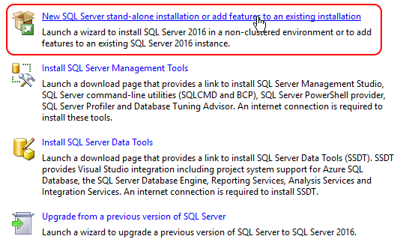
3. Accept all defaults
4. If not already installed on your laptop from a previous installation, also install SQL Server Management Tools
5. Once installation has finished, launch the SQL Server Management Studio in order to create the database and run additional scripts

## Run Script to Create Database

1. Assuming that you used the defaults when setting up SQL Server, and that your Data path is set to **C:\Program Files\Microsoft SQL Server\MSSQL13.SQLEXPRESS\MSSQL\DATA\**  
     
   execute the following SQL Script in a new query window:

|  |
| --- |
| USE [master]  GO  CREATE DATABASE [FRCScouting2019]  CONTAINMENT = NONE  ON PRIMARY  ( NAME = N'FRCScouting2019', FILENAME = N'C:\Program Files\Microsoft SQL Server\MSSQL13.SQLEXPRESS\MSSQL\DATA\FRCScouting2019.mdf' , SIZE = 8192KB , MAXSIZE = UNLIMITED, FILEGROWTH = 65536KB )  LOG ON  ( NAME = N'FRCScouting2019_log', FILENAME = N'C:\Program Files\Microsoft SQL Server\MSSQL13.SQLEXPRESS\MSSQL\DATA\FRCScouting2019_log.ldf' , SIZE = 8192KB , MAXSIZE = 2048GB , FILEGROWTH = 65536KB )  GO  ALTER DATABASE [FRCScouting2019] SET COMPATIBILITY_LEVEL = 130  GO  IF (1 = FULLTEXTSERVICEPROPERTY('IsFullTextInstalled'))  begin  EXEC [FRCScouting2019].[dbo].[sp_fulltext_database] @action = 'enable'  end  GO  ALTER DATABASE [FRCScouting2019] SET ANSI_NULL_DEFAULT OFF  GO  ALTER DATABASE [FRCScouting2019] SET ANSI_NULLS OFF  GO  ALTER DATABASE [FRCScouting2019] SET ANSI_PADDING OFF  GO  ALTER DATABASE [FRCScouting2019] SET ANSI_WARNINGS OFF  GO  ALTER DATABASE [FRCScouting2019] SET ARITHABORT OFF  GO  ALTER DATABASE [FRCScouting2019] SET AUTO_CLOSE OFF  GO  ALTER DATABASE [FRCScouting2019] SET AUTO_SHRINK OFF  GO  ALTER DATABASE [FRCScouting2019] SET AUTO_UPDATE_STATISTICS ON  GO  ALTER DATABASE [FRCScouting2019] SET CURSOR_CLOSE_ON_COMMIT OFF  GO  ALTER DATABASE [FRCScouting2019] SET CURSOR_DEFAULT GLOBAL  GO  ALTER DATABASE [FRCScouting2019] SET CONCAT_NULL_YIELDS_NULL OFF  GO  ALTER DATABASE [FRCScouting2019] SET NUMERIC_ROUNDABORT OFF  GO  ALTER DATABASE [FRCScouting2019] SET QUOTED_IDENTIFIER OFF  GO  ALTER DATABASE [FRCScouting2019] SET RECURSIVE_TRIGGERS OFF  GO  ALTER DATABASE [FRCScouting2019] SET DISABLE_BROKER  GO  ALTER DATABASE [FRCScouting2019] SET AUTO_UPDATE_STATISTICS_ASYNC OFF  GO  ALTER DATABASE [FRCScouting2019] SET DATE_CORRELATION_OPTIMIZATION OFF  GO  ALTER DATABASE [FRCScouting2019] SET TRUSTWORTHY OFF  GO  ALTER DATABASE [FRCScouting2019] SET ALLOW_SNAPSHOT_ISOLATION OFF  GO  ALTER DATABASE [FRCScouting2019] SET PARAMETERIZATION SIMPLE  GO  ALTER DATABASE [FRCScouting2019] SET READ_COMMITTED_SNAPSHOT OFF  GO  ALTER DATABASE [FRCScouting2019] SET HONOR_BROKER_PRIORITY OFF  GO  ALTER DATABASE [FRCScouting2019] SET RECOVERY SIMPLE  GO  ALTER DATABASE [FRCScouting2019] SET MULTI_USER  GO  ALTER DATABASE [FRCScouting2019] SET PAGE_VERIFY CHECKSUM  GO  ALTER DATABASE [FRCScouting2019] SET DB_CHAINING OFF  GO  ALTER DATABASE [FRCScouting2019] SET FILESTREAM( NON_TRANSACTED_ACCESS = OFF )  GO  ALTER DATABASE [FRCScouting2019] SET TARGET_RECOVERY_TIME = 60 SECONDS  GO  ALTER DATABASE [FRCScouting2019] SET DELAYED_DURABILITY = DISABLED  GO  ALTER DATABASE [FRCScouting2019] SET QUERY_STORE = OFF  GO  USE [FRCScouting2019]  GO  ALTER DATABASE SCOPED CONFIGURATION SET MAXDOP = 0;  GO  ALTER DATABASE SCOPED CONFIGURATION FOR SECONDARY SET MAXDOP = PRIMARY;  GO  ALTER DATABASE SCOPED CONFIGURATION SET LEGACY_CARDINALITY_ESTIMATION = OFF;  GO  ALTER DATABASE SCOPED CONFIGURATION FOR SECONDARY SET LEGACY_CARDINALITY_ESTIMATION = PRIMARY;  GO  ALTER DATABASE SCOPED CONFIGURATION SET PARAMETER_SNIFFING = ON;  GO  ALTER DATABASE SCOPED CONFIGURATION FOR SECONDARY SET PARAMETER_SNIFFING = PRIMARY;  GO  ALTER DATABASE SCOPED CONFIGURATION SET QUERY_OPTIMIZER_HOTFIXES = OFF;  GO  ALTER DATABASE SCOPED CONFIGURATION FOR SECONDARY SET QUERY_OPTIMIZER_HOTFIXES = PRIMARY;  GO  ALTER DATABASE [FRCScouting2019] SET READ_WRITE  GO |

1. Next create the table that will store the Scouting data using the following script:

|  |
| --- |
| USE [FRCScouting2019]  GO  /****** Object: Table [dbo].[FRCScoutingTeam3932] Script Date: 3/10/2019 8:19:13 AM ******/  SET ANSI_NULLS ON  GO  SET QUOTED_IDENTIFIER ON  GO  CREATE TABLE [dbo].[FRCScoutingTeam3932] (  [DeviceID] [varchar](100) NOT NULL,  [ID] [uniqueidentifier] NOT NULL,  [Team] [int] NOT NULL,  [Ally1] [int] NOT NULL,  [Ally2] [int] NOT NULL,  [Game] [int] NOT NULL,  [AutoDescendPlatform] [int] NULL,  [AutoPlaceHatch] [int] NULL,  [AutoPlaceCargo] [int] NULL,  [TelePlaceHatchLow] [int] NULL,  [TelePlaceHatchMed] [int] NULL,  [TelePlaceHatchHigh] [int] NULL,  [TelePlaceCargoLow] [int] NULL,  [TelePlaceCargoMed] [int] NULL,  [TelePlaceCargoHigh] [int] NULL,  [TeleHabHeight] [int] NULL,  [TeleDefensePlayed] [int] NULL,  [Alliance] [varchar](100) NULL,  [Station] [int] NULL,  [CreatedAt] [datetime] NULL,  CONSTRAINT [PK_FRCScoutingTeam3932] PRIMARY KEY CLUSTERED  (  [ID] ASC  )WITH (PAD_INDEX = OFF, STATISTICS_NORECOMPUTE = OFF, IGNORE_DUP_KEY = OFF, ALLOW_ROW_LOCKS = ON, ALLOW_PAGE_LOCKS = ON) ON [PRIMARY]  ) ON [PRIMARY]  GO |

1. Also create a table that will be used to store the weights we choose to assign to different robot abilities

|  |
| --- |
| USE [FRCScouting2019]  GO  /****** Object: Table [dbo].[FRCScoutingTeam3932_AttributeWeights] Script Date: 3/10/2019 10:28:22 AM ******/  SET ANSI_NULLS ON  GO  SET QUOTED_IDENTIFIER ON  GO  CREATE TABLE [dbo].[FRCScoutingTeam3932_AttributeWeights](  [ID] [int] IDENTITY(1,1) NOT NULL,  [PointsAutoDescendPlatform1] [int] NULL,  [PointsAutoDescendPlatform2] [int] NULL,  [PointsAutoPlaceHatch] [int] NULL,  [PointsAutoPlaceCargo] [int] NULL,  [PointsTelePlaceHatchLow] [int] NULL,  [PointsTelePlaceHatchMed] [int] NULL,  [PointsTelePlaceHatchHigh] [int] NULL,  [PointsTelePlaceCargoLow] [int] NULL,  [PointsTelePlaceCargoMed] [int] NULL,  [PointsTelePlaceCargoHigh] [int] NULL,  [PointsTeleHabHeight1] [int] NULL,  [PointsTeleHabHeight2] [int] NULL,  [PointsTeleHabHeight3] [int] NULL,  [PointsTeleDefensePlayed] [int] NULL,  PRIMARY KEY CLUSTERED  (  [ID] ASC  )WITH (PAD_INDEX = OFF, STATISTICS_NORECOMPUTE = OFF, IGNORE_DUP_KEY = OFF, ALLOW_ROW_LOCKS = ON, ALLOW_PAGE_LOCKS = ON) ON [PRIMARY]  ) ON [PRIMARY]  GO  SET IDENTITY_INSERT [dbo].[FRCScoutingTeam3932_AttributeWeights] ON  INSERT [dbo].[FRCScoutingTeam3932_AttributeWeights] ([ID], [PointsAutoDescendPlatform1], [PointsAutoDescendPlatform2], [PointsAutoPlaceHatch], [PointsAutoPlaceCargo], [PointsTelePlaceHatchLow], [PointsTelePlaceHatchMed], [PointsTelePlaceHatchHigh], [PointsTelePlaceCargoLow], [PointsTelePlaceCargoMed], [PointsTelePlaceCargoHigh], [PointsTeleHabHeight1], [PointsTeleHabHeight2], [PointsTeleHabHeight3], [PointsTeleDefensePlayed]) VALUES (1, 10, 20, 15, 15, 8, 10, 12, 10, 12, 15, 10, 20, 40, 5)  SET IDENTITY_INSERT [dbo].[FRCScoutingTeam3932_AttributeWeights] OFF |

1. Create a view named vw_FRCScouting3932_GameTeam by running the following script

|  |
| --- |
| USE [FRCScouting2019]  GO  /****** Object: View [dbo].[vw_FRCScounting2018_GameTeam] Script Date: 3/10/2019 8:37:22 AM ******/  SET ANSI_NULLS ON  GO  SET QUOTED_IDENTIFIER ON  GO  CREATE VIEW [dbo].[vw_FRCScounting3932_GameTeam]  AS  WITH cteView AS (  SELECT  s.Game  , s.Team  , CAST(s.Game AS VARCHAR(10)) + '-' + CAST(s.Team AS VARCHAR(10)) AS [GameTeam]  , CASE  WHEN s.[AutoDescendPlatform] = 1 THEN p.[PointsAutoDescendPlatform1]  WHEN s.[AutoDescendPlatform] = 2 THEN p.[PointsAutoDescendPlatform2]  ELSE 0  END AS [AutoDescendPlatform]  , ISNULL(s.[AutoPlaceHatch], 0) * p.[PointsAutoPlaceHatch] AS [AutoPlaceHatch]  , ISNULL(s.[AutoPlaceCargo], 0) * p.[PointsAutoPlaceCargo] AS [AutoPlaceCargo]  , ISNULL(s.[TelePlaceHatchLow], 0) * p.[PointsTelePlaceHatchLow] AS [TelePlaceHatchLow]  , ISNULL(s.[TelePlaceHatchMed], 0) * p.[PointsTelePlaceHatchMed] AS [TelePlaceHatchMed]  , ISNULL(s.[TelePlaceHatchHigh], 0) * p.[PointsTelePlaceHatchHigh] AS [TelePlaceHatchHigh]  , ISNULL(s.[TelePlaceCargoLow], 0) * p.[PointsTelePlaceCargoLow] AS [TelePlaceCargoLow]  , ISNULL(s.[TelePlaceCargoMed], 0) * p.[PointsTelePlaceCargoMed] AS [TelePlaceCargoMed]  , ISNULL(s.[TelePlaceCargoHigh], 0) * p.[PointsTelePlaceCargoHigh] AS [TelePlaceCargoHigh]  , CASE  WHEN s.[TeleHabHeight] = 1 THEN p.[PointsTeleHabHeight1]  WHEN s.[TeleHabHeight] = 2 THEN p.[PointsTeleHabHeight2]  WHEN s.[TeleHabHeight] = 3 THEN p.[PointsTeleHabHeight3]  ELSE 0  END AS [TeleHabHeight]  , ISNULL(s.[TeleDefensePlayed], 0) * p.[PointsTeleDefensePlayed] AS [TeleDefensePlayed]  FROM dbo.FRCScoutingTeam3932 AS s WITH (NOLOCK)  INNER JOIN FRCScoutingTeam3932_AttributeWeights AS p WITH (NOLOCK) ON p.ID = (SELECT TOP 1 ID FROM FRCScoutingTeam3932_AttributeWeights WITH (NOLOCK) ORDER BY ID DESC)  )  SELECT  cte.Team  , cte.[AutoDescendPlatform]  , cte.[AutoPlaceHatch]  , cte.[AutoPlaceCargo]  , cte.[TelePlaceHatchLow]  , cte.[TelePlaceHatchMed]  , cte.[TelePlaceHatchHigh]  , cte.[TelePlaceCargoLow]  , cte.[TelePlaceCargoMed]  , cte.[TelePlaceCargoHigh]  , cte.[TeleHabHeight]  , cte.[TeleDefensePlayed]  , (cte.[AutoDescendPlatform] + cte.[AutoPlaceHatch] + cte.[AutoPlaceCargo]) AS [AutonomousAggregate]  , (cte.[TelePlaceHatchLow] + cte.[TelePlaceHatchMed] + cte.[TelePlaceHatchHigh] + cte.[TelePlaceCargoLow] + cte.[TelePlaceCargoMed] + cte.[TelePlaceCargoHigh] + cte.[TeleHabHeight] + cte.[TeleDefensePlayed]) AS [TeleOpAggregate]  , (cte.[AutoDescendPlatform] + cte.[AutoPlaceHatch] + cte.[AutoPlaceCargo] + cte.[TelePlaceHatchLow] + cte.[TelePlaceHatchMed] + cte.[TelePlaceHatchHigh] + cte.[TelePlaceCargoLow] + cte.[TelePlaceCargoMed] + cte.[TelePlaceCargoHigh] + cte.[TeleHabHeight] + cte.[TeleDefensePlayed]) AS [OverallAggregate]  FROM cteView AS cte  GO |

## Use Excel to create the reports on the games

1. Open Excel 2016
2. Use the ribbon menu to add a new query to the data we have imported  
   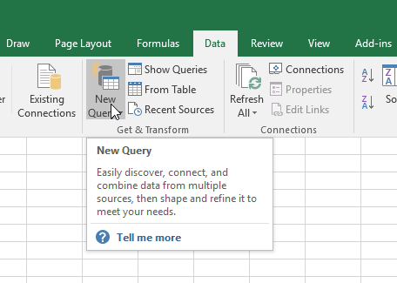
3. Choose SQL Server as your data source  
   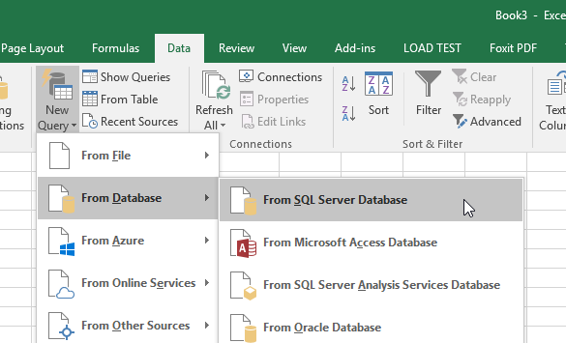
4. Expand the “Advanced Options” section and set the Server to “localhost\SQLEXPRESS” and the Database to “FRCScouting2019” (assuming that you used the recommended names for those entities)  
   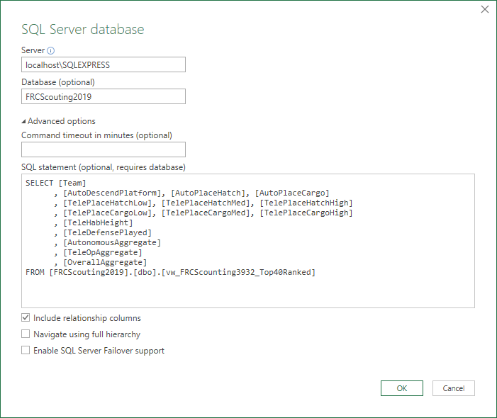
5. Copy and paste the following script into the “SQL statement (optional)” text area:

|  |
| --- |
| SELECT [Team]  , [AutoDescendPlatform], [AutoPlaceHatch], [AutoPlaceCargo]  , [TelePlaceHatchLow], [TelePlaceHatchMed], [TelePlaceHatchHigh]  , [TelePlaceCargoLow], [TelePlaceCargoMed], [TelePlaceCargoHigh]  , [TeleHabHeight]  , [TeleDefensePlayed]  , [AutonomousAggregate]  , [TeleOpAggregate]  , [OverallAggregate]  FROM [FRCScouting2019].[dbo].[vw_FRCScounting3932_Top40Ranked] |

1. The first time you try connecting to the SQL Server, you will receive a security prompt. Assuming you setup the SQL Server with defaults (i.e. Windows login for the administrator), you may just click Connect   
   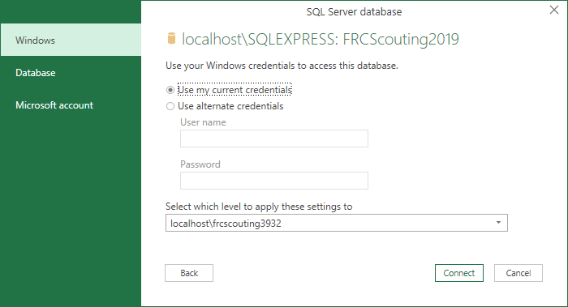
2. Once you connect, a confirmation dialog showing the data returned by your query is displayed  
   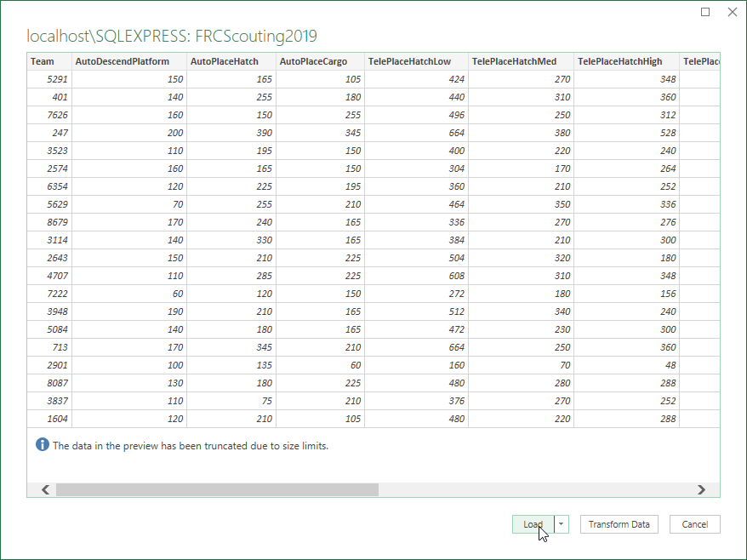
3. Press “Load” and the data will be loaded into a new sheet in your workbook  
   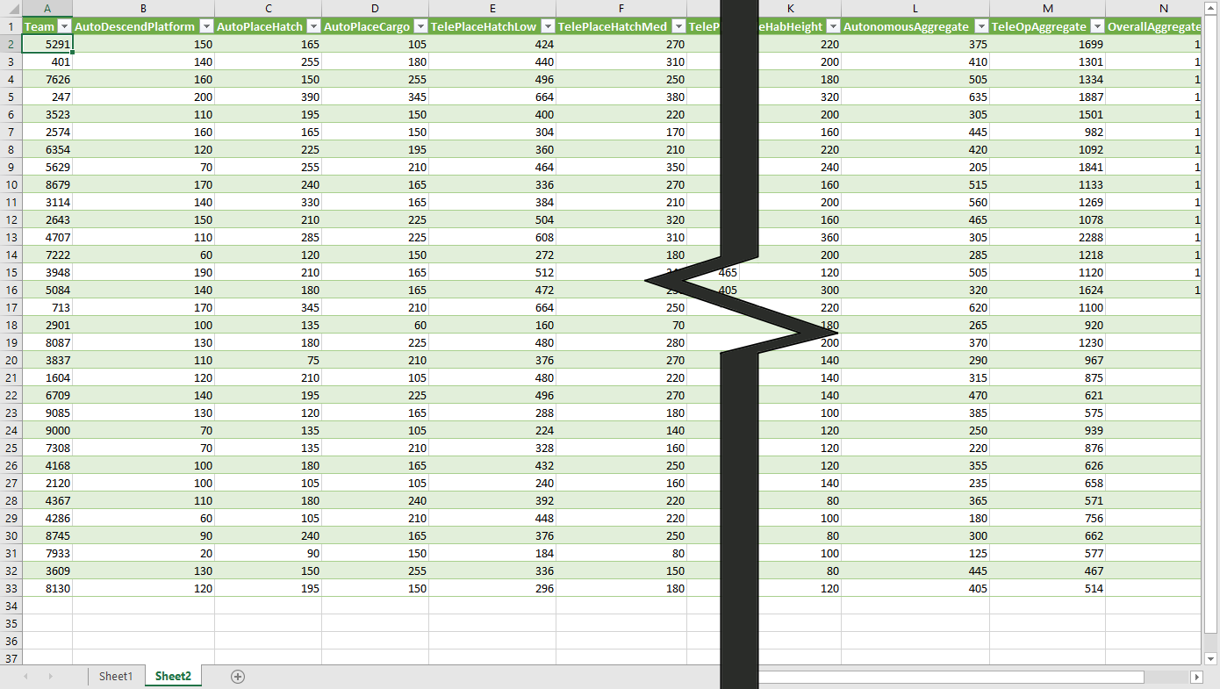
4. Now, each of the columns can be used for filtering or sorting the data according to whatever criteria we may want to focus on.